1. **Explore your project and find all options discussed in lecture 2 from Chapter 2. You need to prepare a google doc that highlights the potential issue that your code has. You may identify these issues with the help of**

**i) Identify deprecated technology or APIs. Just report the diagram.**

The model uses Firebase version that was released on October 16, 2018. There are newer versions of Firebase available now but it has not been updated for the project.

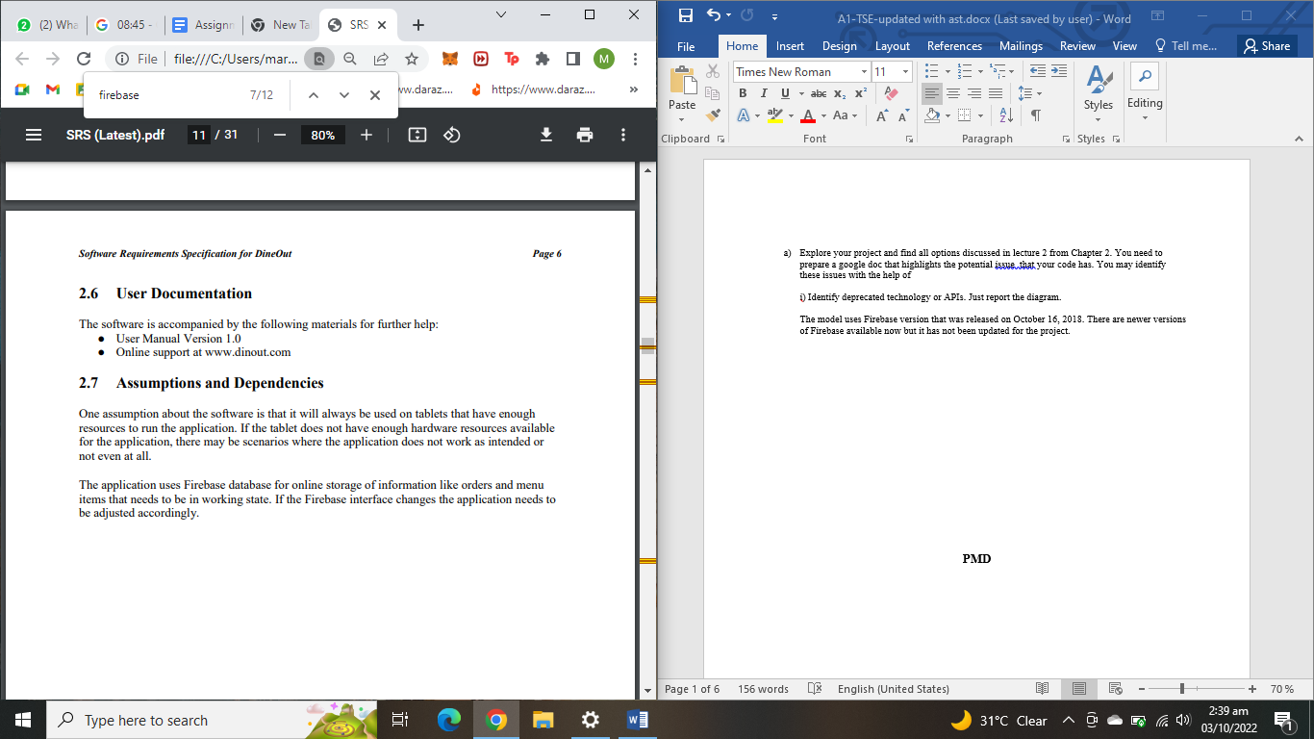

**ii) Potential issues missing in the documentation but available in the code**

Following are the issues missing in the documentation but available in the code**:**

* Pending Payment
* Notification implementation
* End of week activity
* Table with attributes

1. **Missing of technical documentation(if applicable)**

Not applicable as per the project selected

1. **Use PMD to help identify potential coding errors and customize the rules you use to make sure only pertinent rules are applied to your source code.**

**Note:**

**All 5 parts of section b) have been implemented together**

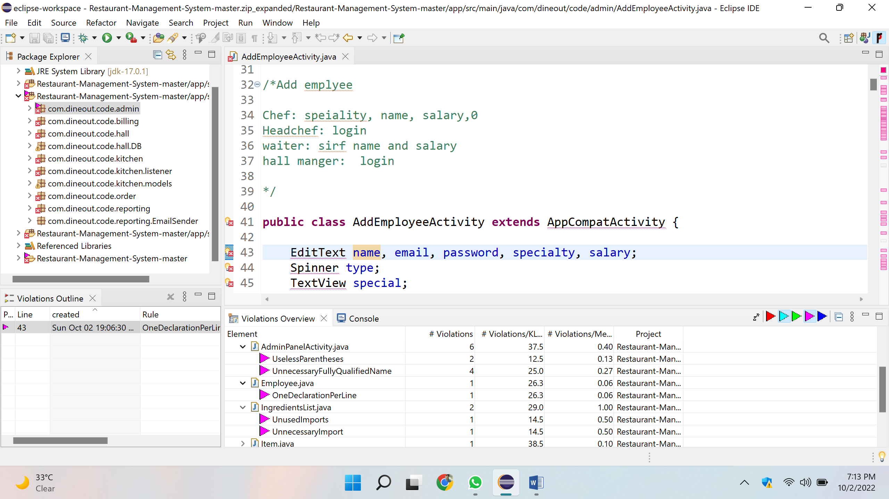

Rules that we have explore of PMD after running it on Restaurant-Management-System-master/app/src/main/java/admin:

* **UnusedImport**

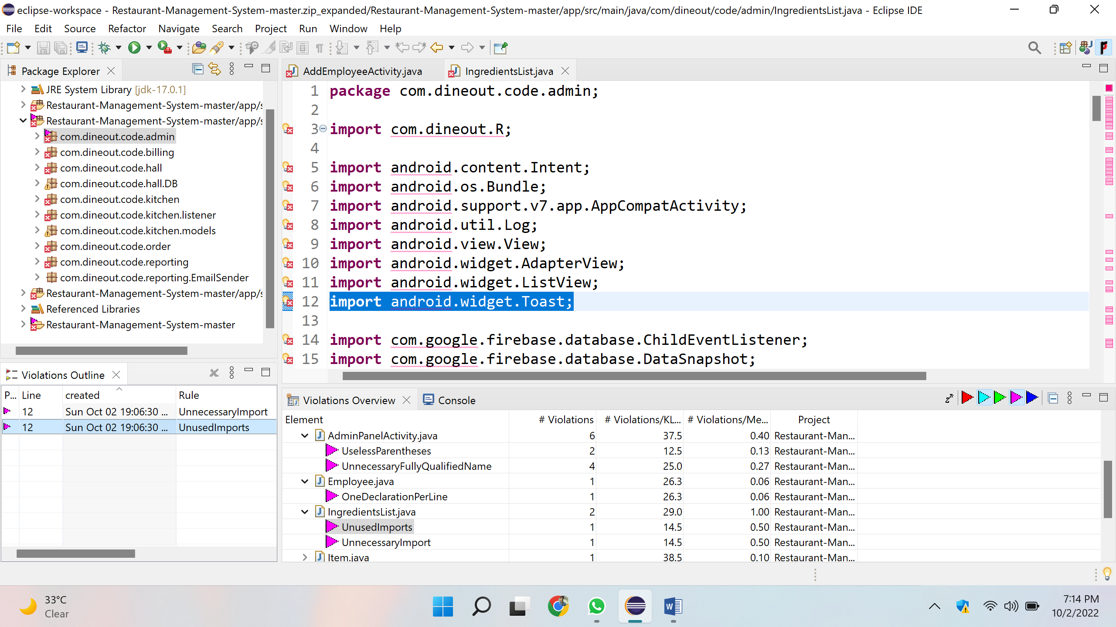

* **OneDeclarationPerLine**

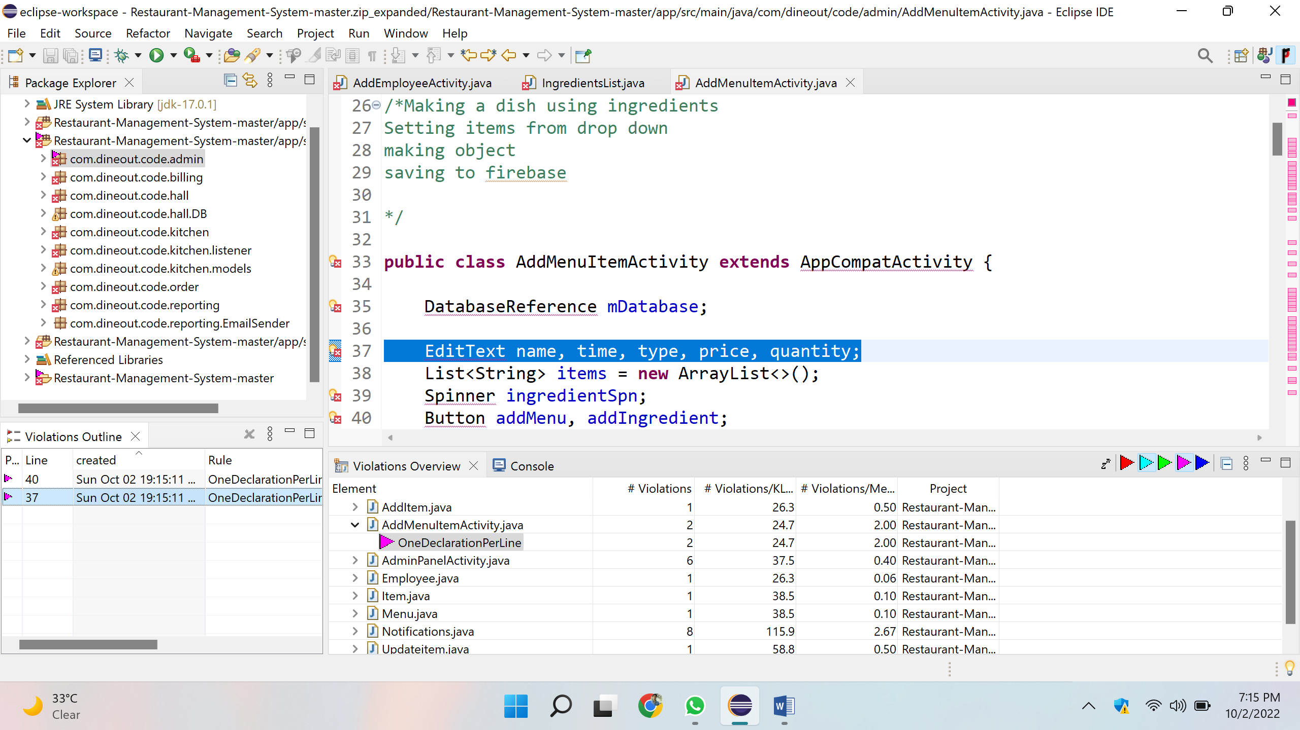

* **uselassParentheses**

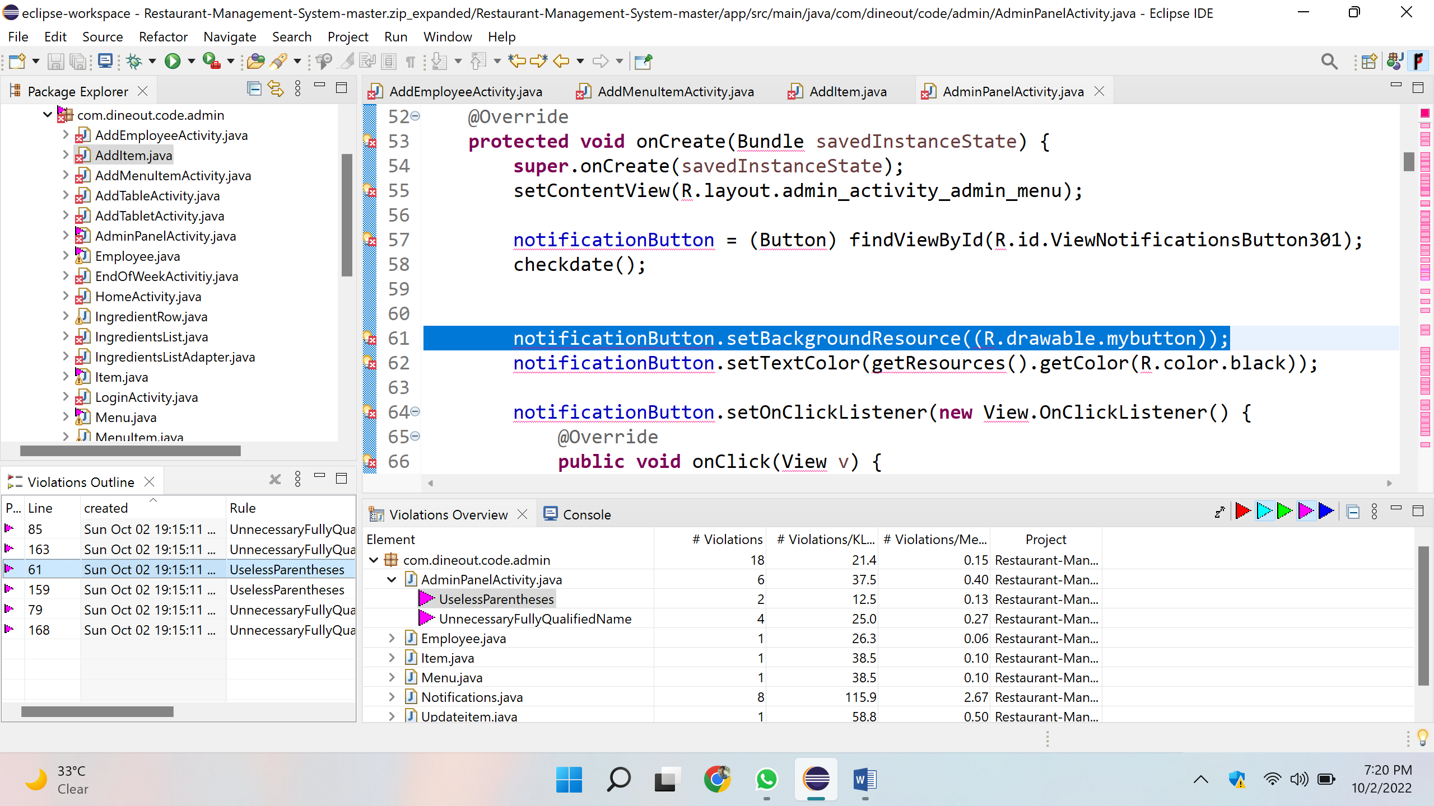

After exploring the rules and correction of voilations.

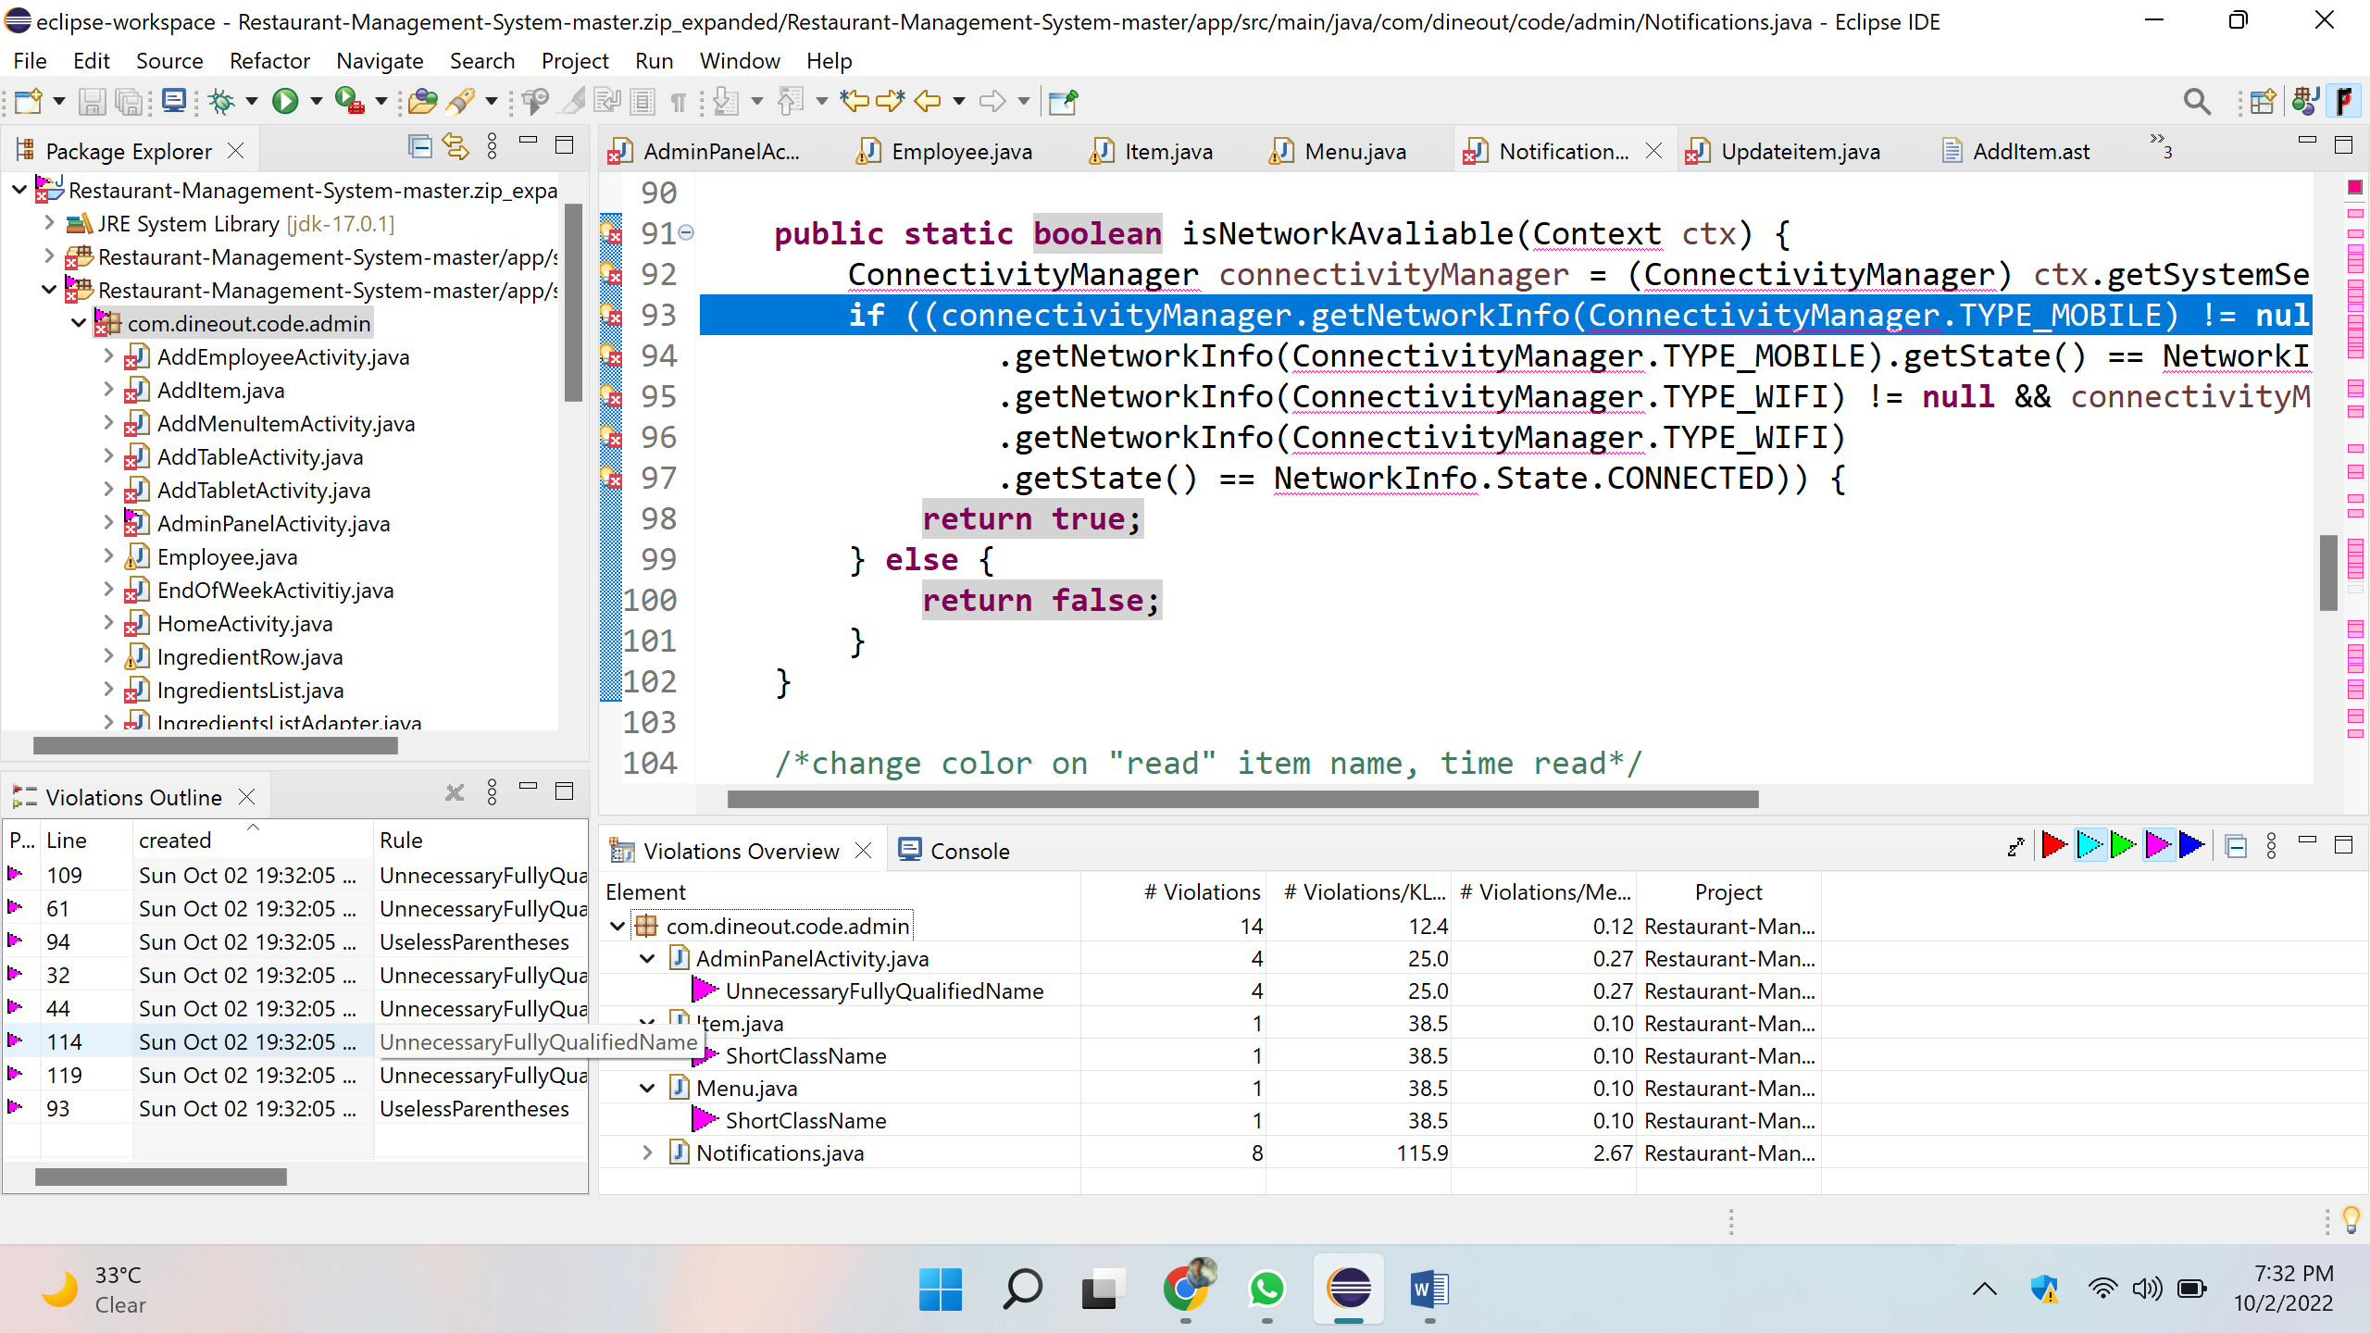

AST(Abstract Syntax Tree) Of Additem.java

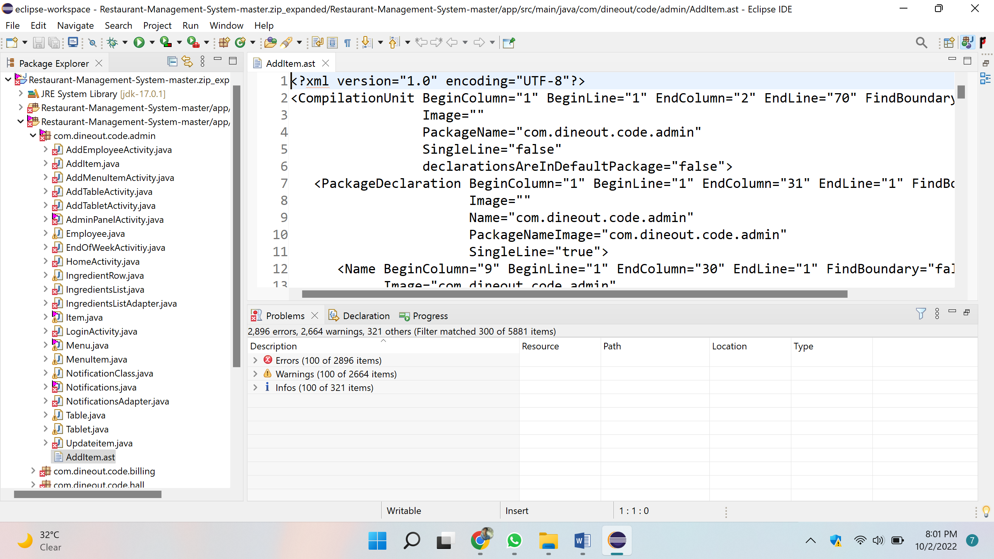

1. **Use the Check Style tool to review your code. At least apply 2 rules on your code using CHeckStyle**

**Checkstyle**

**Rule No 1:**

{' at column 5 should be on the previous line.

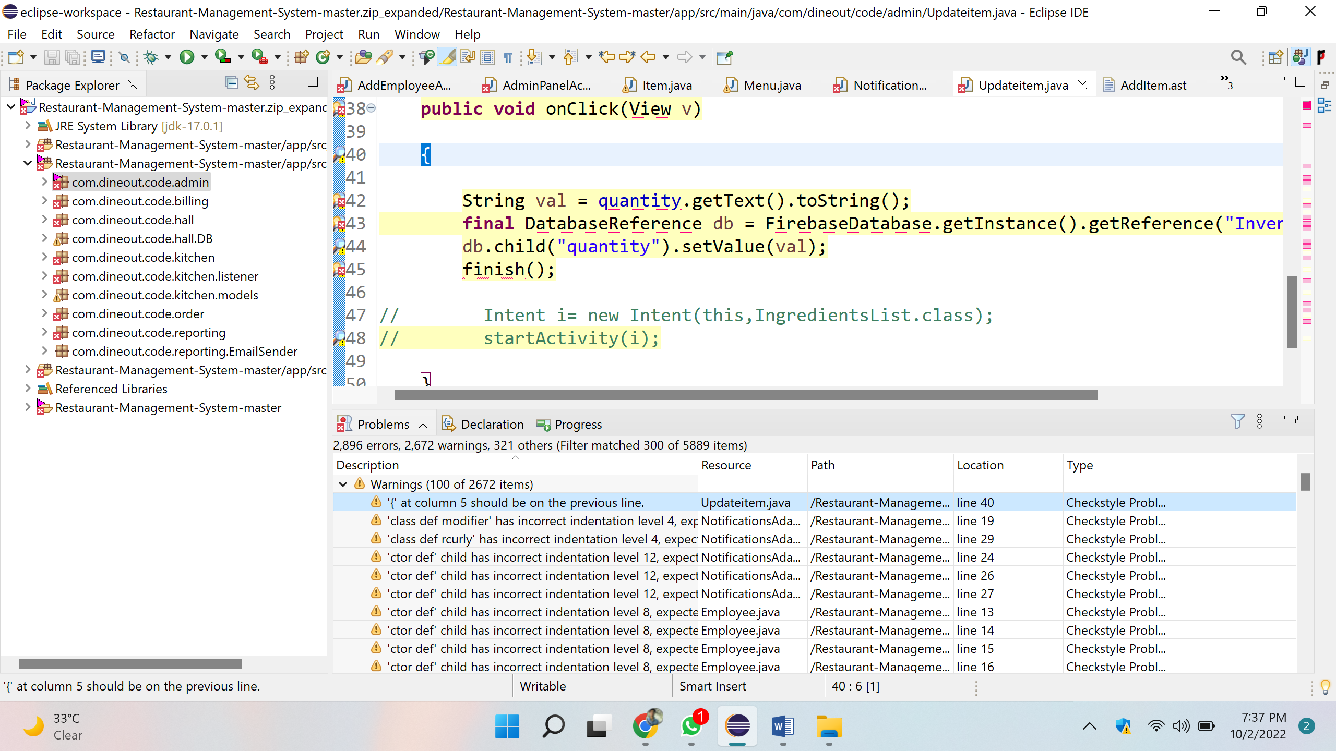

**Solution:**

Moving the curly braces on previous line.

**Rule No 2**

'ctor def' child has incorrect indentation level 8, expected level should be 4.

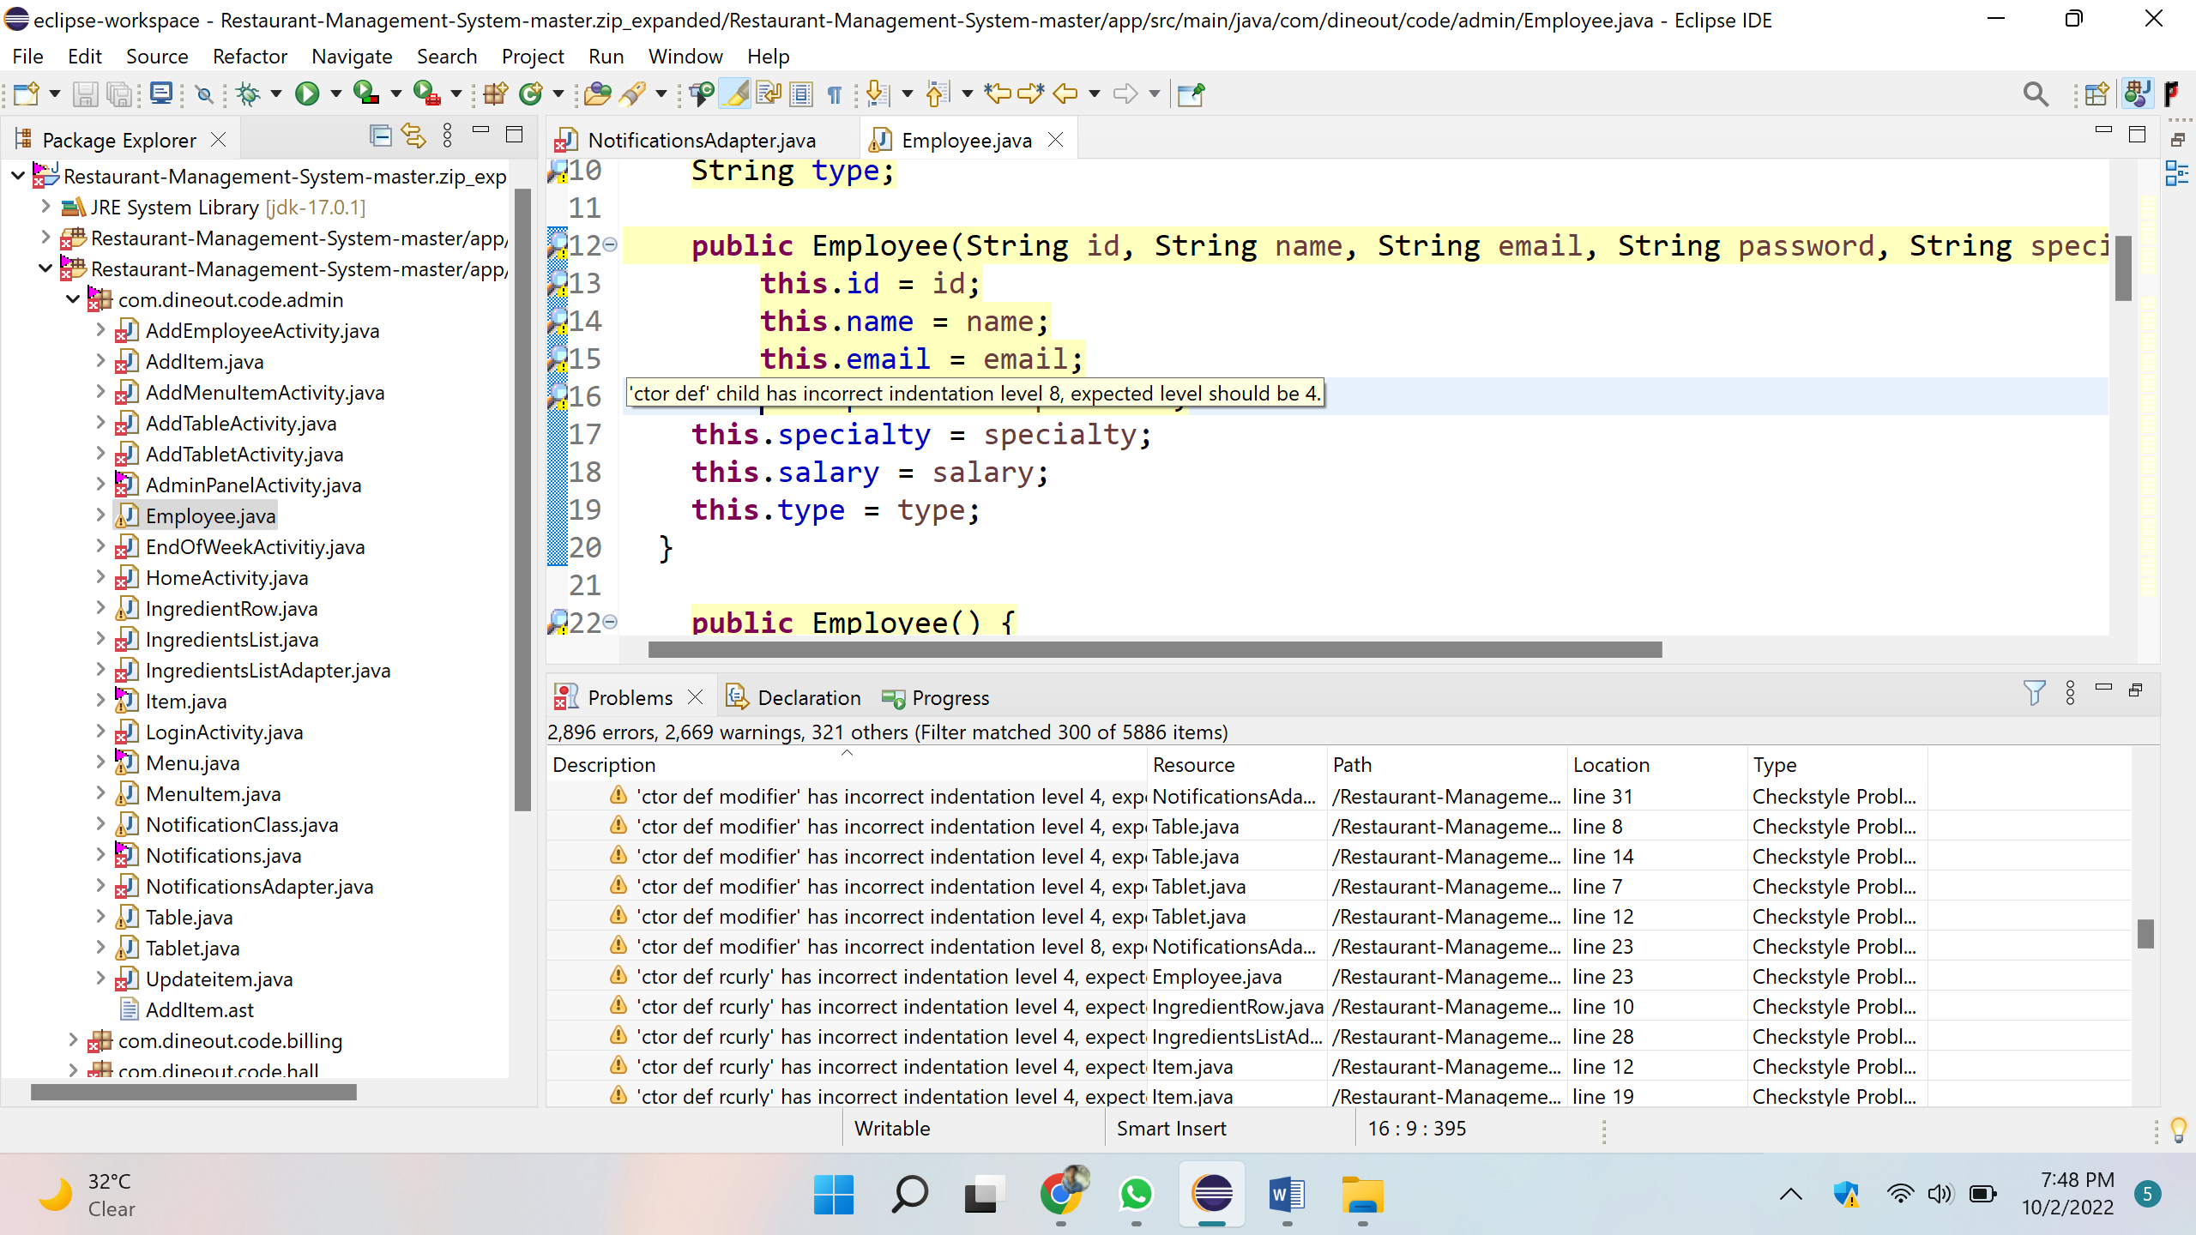

**Solution:**

By removing the 4 white spaces before the line.